**Project Report**

**1.INTRODUCTION**

* 1. **overview**

Start with a brief, engaging introduction that captures the essence of your restaurant in a sentence or two.

**Cuisine:**

Describe the type of cuisine your restaurant offers, whether it's Italian, Chinese, American, fusion, etc.

Highlight any specialties or signature dishes that set your restaurant apart.

**Atmosphere:**

Discuss the ambiance and style of your restaurant. Is it cozy and romantic, casual and family-friendly, or elegant and upscale?

Mention any unique decor or design features that enhance the dining experience.

**Location:**

Provide the address and any notable landmarks or proximity to popular attractions.

Include information about parking options and public transportation access if applicable**.**

**Chef and Culinary Team:**

Spotlight the chef or culinary team responsible for crafting the menu.

Share any culinary awards or special qualifications they hold.

**1.2 Purpose**

**Culinary Excellence:**

Many restaurants focus on delivering outstanding, innovative, or traditional cuisine. Their purpose is to showcase culinary skills and create exceptional dining experiences.

**Customer Satisfaction:**

A primary purpose for most restaurants is to provide high-quality service, ensuring guests have a memorable and enjoyable dining experience.

**Community Gathering:**

Some restaurants aim to be a hub for the local community, where people come together to socialize, celebrate special occasions, and build connections.

**Cultural Representation**:

Certain restaurants focus on representing and celebrating a particular culture's cuisine, aiming to educate and immerse diners in the flavors and traditions of that culture.

**Eating:**

For health-conscious restaurants, the purpose is to offer nutritious, wholesome, and balanced meal options that promote well-being.

**Sustainability:**

Restaurants that prioritize sustainability aim to source ingredients responsibly, reduce waste, and operate in an environmentally friendly manner.

**Local Sourcing:**

Some restaurants have a purpose of supporting local farmers and businesses by using locally sourced ingredients, promoting the local economy.

**Entertainment:**

Restaurants with this purpose may offer live music, themed nights, or other forms of entertainment to create a lively and engaging atmosphere.

**Affordability:**

For budget-friendly restaurants, the purpose is to provide delicious meals at an affordable price point, making dining out accessible to a wide range of customers.

**Fine Dining and Elegance:**

High-end or fine dining restaurants focus on providing a luxurious and sophisticated dining experience, often targeting special occasions and upscale clientele.

**Education:**

Some restaurants offer cooking classes, wine tastings, or other educational experiences to teach customers about the culinary arts and food and beverage pairings.

**Social Responsibility:**

Restaurants with a strong sense of social responsibility may have a purpose of giving back to the community through charitable initiatives or supporting local causes.

**Innovation:**

These restaurants push the boundaries of traditional cuisine and techniques, focusing on creativity and pushing culinary limits.

**2.Problem Definition & Design Thinking**

**2.1 Empathy map**

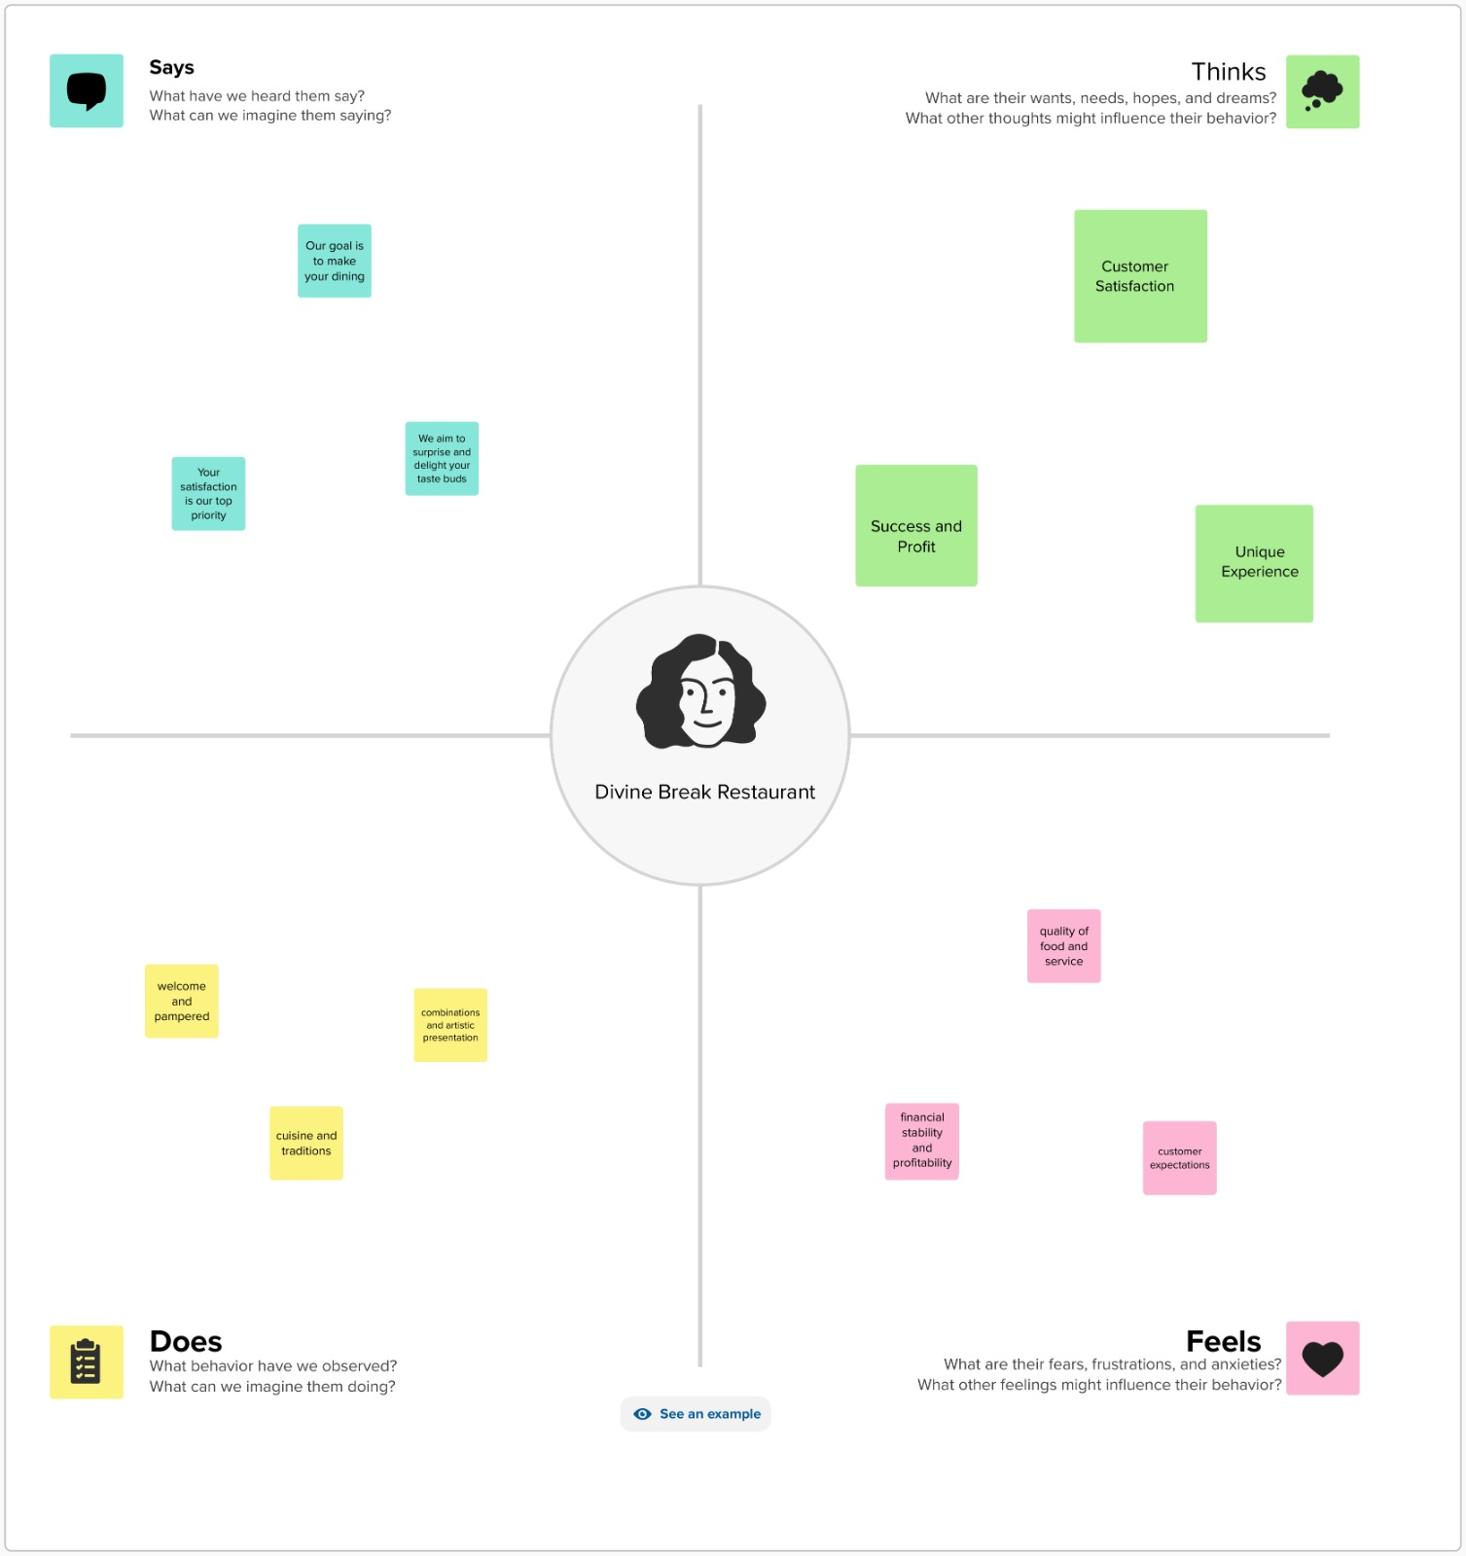

**2.2 Ideation & brainstorming map**

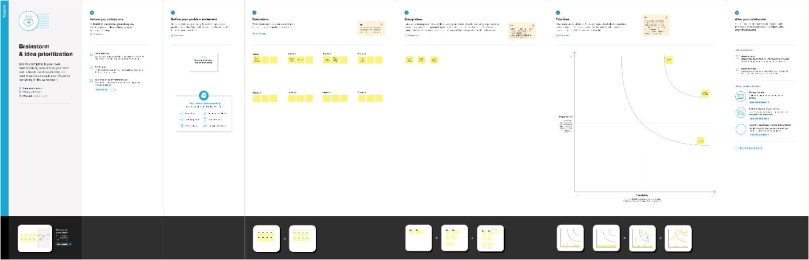

**Result :**



**4.Advantages & Disadvantages**

**Advantage:**

1.Event Hosting

2. Brand Loyalty

3. Passion and Creativity

**Disadvantage:**

1. Intense Competition

2. Economic Factors

**5.Application**

1. Hotel Management

2.Cafeteria

3.Office

**6.Conclusion**

Writing a compelling conclusion for a restaurant involves summarizing key points and leaving a lasting impression. Your conclusion should make readers or potential customers feel excited and eager to visit or learn more about your restaurant.